End of unit 6 test Name:
- Translate 10

Potraviny
Utratit za
Spodní prádlo
Pohodový
Ambiciozní
Rozpadat se
Čočka
Vděčný
Tekoucí voda
dobytek

- Translate questions, answer them using whole sentences. 12

Po kom jsi?
Jaký je tvůj nejlepší přítel?
Jak se má tvůj manžel?
Jsou si tvé děti podobné?
Jak vypadá tvá matka?
Máš ráda čokoládu?
- How do you say, when… 4
Two people are totally different
You don´t talk to someone
When someone constantly upsets you
When one day have good relationship with someone and the next day you argue
- Choose correct forms of the adjectives 7
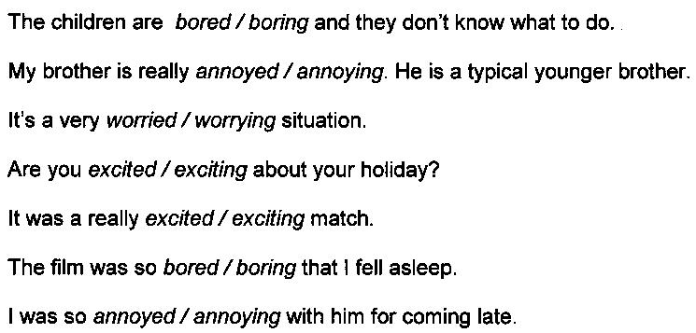

- Translate given vocabulary and write down a department in a department store where you could find these 16
TRANSLATION DEPARTMENT
wallet
blow dry
highlights
linen
lingerie
saucepan
birthday card
pair of tights
- Complete the compound adjectives with the missing part. 10
1 My parents are really old-fashioned. They want to meet every girl I mention.
2 Our neighbours have got really ____-behaved children. They are so rude.
3 Is this car new? Or did you buy it ____-hand?
4 Angela’s a ____-working employee. She should get a better salary.
5 Coldplay is ____-famous. People in every country know the band.
6 Her parents are quite ____-going. They don’t worry about what she does.
7 I don’t work ____-time. I only do four hours a day.
8 David Beckham is a good-____ man.
9 First-____ children are more responsible than their younger brothers and sisters.
10 My sister’s bought me a brand-____ camera. It’s much better than my old one.
11 Rolls-Royce cars are not built by robots. They are still hand-____.

